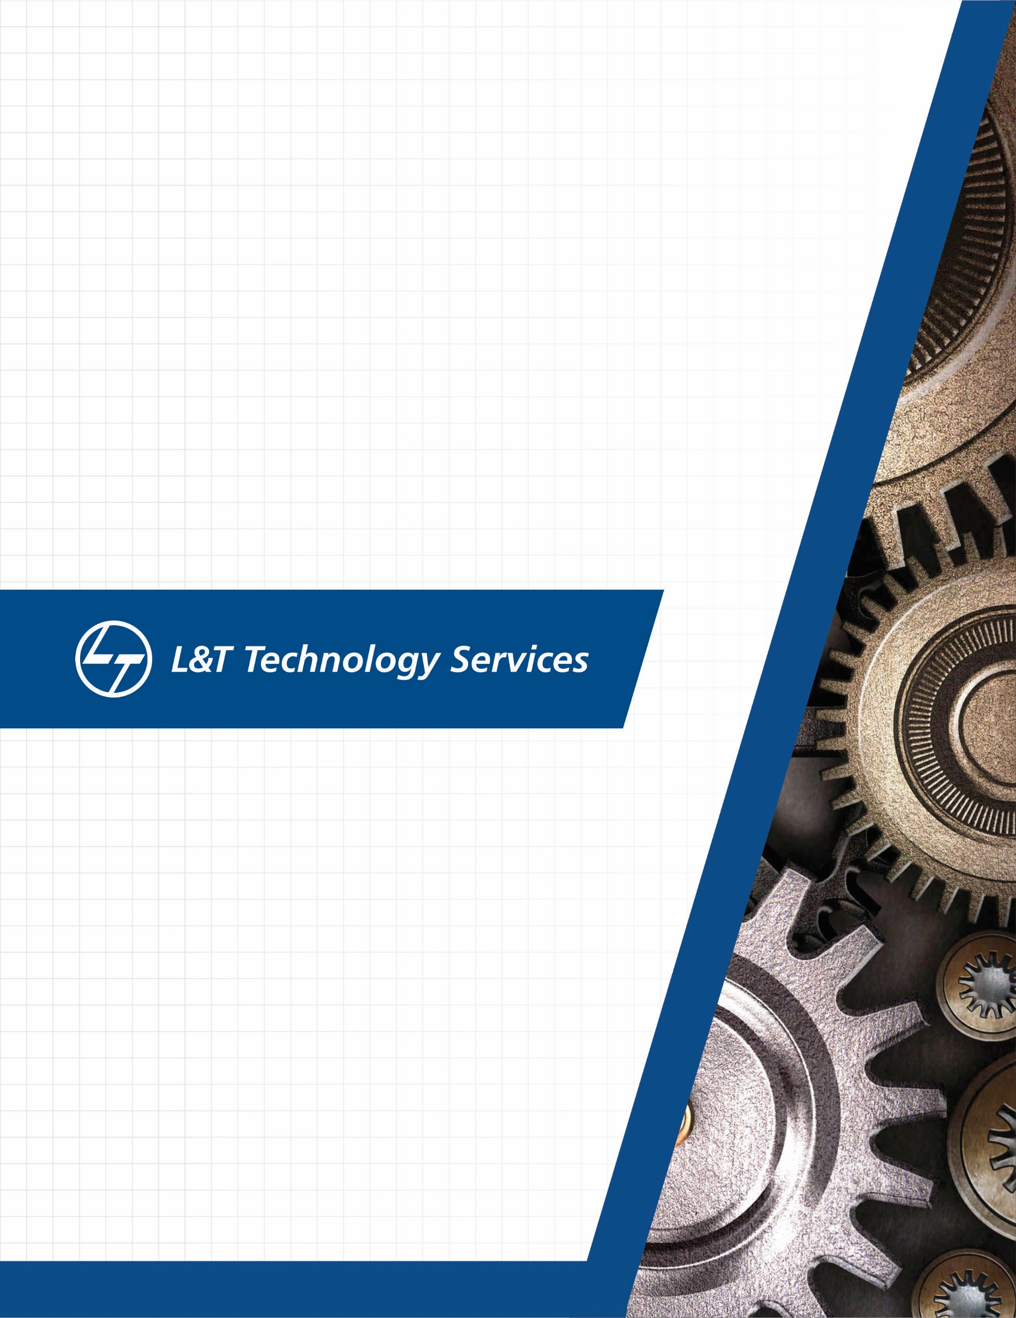
./
Learning Report Networking


Ver.Rel. No. | Release Date | Prepared. By | Reviewed By | To be approved By | Remarks/Revision Details
1 |  | Name/PS No | Name/PS No | Module Owner Name | Comments
2 | 01/03/21 | 99003772
3
Document History

Contents
Transmission Modes: 5
Types of Topology: 7
NETWORK DEVICES: 14
Network device are physical devices that are required for communication and interaction between hardware on a computer network. 14
Types of network devices - 14
Routing Table - 20
Types of Routers – 20
Bridge - 21
Gateway – 23
Types of Gateways - 24
Repeater - 25
Types of Repeaters - 27
MODEM – 27
Types of Modem 28
OSI MODEL: 28
Physical layer 30
Data Link Layer 30
Network layer 31
Transport Layer 32
Functions of Transport Layer: 33
SESSION LAYER: 34
PRESENTATION LAYER: 34
APPLICATION LAYER: 35
WIRELESS COMMUNICATION 36
HISTORY OF WIRELSS COMMUNICATION: 36
GENERATIONS OF WIRELESS COMMUNICATION: 39
1G: 39
2G: 40
3G: 40
4G: 41
5G: 42

Transmission Modes:
- The way in which data is transmitted from one device to another device is known as transmission mode.
- The transmission mode is also known as the communication mode.
- Each communication channel has a direction associated with it, and transmission media provide the direction. Therefore, the transmission mode is also known as a directional mode.
- The transmission mode is defined in the physical layer.
The Transmission mode is divided into three categories:
- Simplex mode
- Half-duplex mode
- Full-duplex mode

1.Simplex mode: In Simplex mode, the communication is unidirectional, as on a one-way street. Only one of the two devices on a link can transmit, the other can only receive. The simplex mode can use the entire capacity of the channel to send data in one direction.
Example: Keyboard and traditional monitors. The keyboard can only introduce input, the monitor can only give the output.
Advantage of Simplex mode: In simplex mode, the station can utilize the entire bandwidth of the communication channel, so that more data can be transmitted at a time.

Disadvantage of Simplex mode: Communication is unidirectional, so it has no inter-communication between devices.
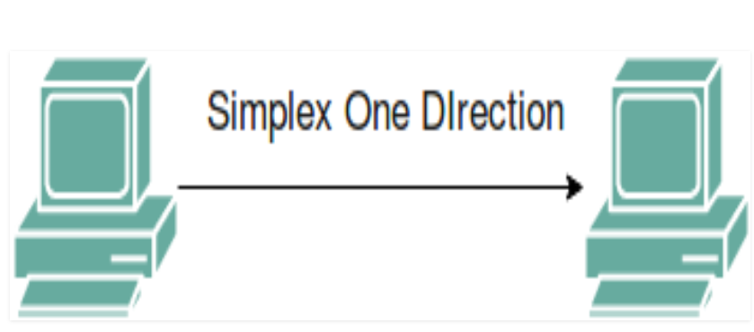
2. Half-Duplex Mode: In half-duplex mode, each station can both transmit and receive, but not at the same time. When one device is sending, the other can only receive, and vice versa. The half-duplex mode is used in cases where there is no need for communication in both direction at the same time. The entire capacity of the channel can be utilized for each direction.
Example: Walkie- talkie in which message is sent one at a time and messages are sent in both the directions.
Channel capacity=Bandwidth * Propagation Delay
Advantage of half-duplex mode: Both devices can send and receive data. Whole bandwidth can be utilized as at a time only one signal transmits.
Disadvantage of half-duplex mode: The disadvantage in half duplex mode is that the other device cannot send data until it receives the data which is already in transmission, this can cause delays to the communication.
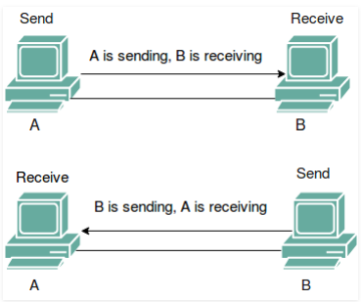
3. Full-Duplex Mode: In full-duplex mode, both stations can transmit and receive simultaneously. In full-duplex mode, signals going in one direction share the capacity of the link with signals going in other direction, this sharing can occur in two ways:
- Either the link must contain two physically separate transmission paths, one for sending and other for receiving.
- Or the capacity is divided between signals travelling in both directions.
Full-duplex mode is used when communication in both direction is required all the time. The capacity of the channel, however must be divided between the two directions.
Example: Telephone Network in which there is communication between two persons by a telephone line, through which both can talk and listen at the same time.
Channel Capacity=2* Bandwidth*propagation Delay.
Advantage of half-duplex mode: The speed of full-duplex mode is high than simplex and half-duplex mode. Data can be sent and receive on both sides, which increases the performance of the network. No delay in communication, because both devices send and receive data at the same time.
Disadvantage of half-duplex mode: The disadvantage in half duplex mode is that the other device cannot send data until it receives the data which is already in transmission, this can cause delays to the communication.
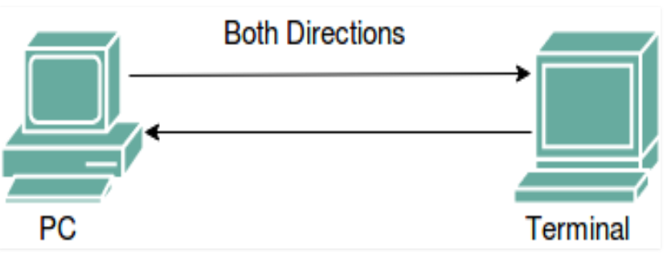
Topology: Topology defines the structure of the network of how all the components are interconnected to each other. There are two types of topology: physical and logical topology.
Physical topology is the geometric representation of all the nodes in a network.

Types of Topology:
There are five types of topology in computer networks:
1.Mesh Topology
2.Star Topology
3.Bus Topology
4.Ring Topology
5.Tree Topology
6.Hybrid Topology
Mesh Topology: In mesh topology, every device is connected to another device via particular channel.
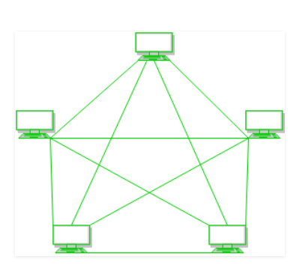
Figure 1: Every device is connected with another via dedicated channels. These channels are known as links.
- If suppose, N number of devices are connected with each other in mesh topology, then total number of ports that is required by each device is? N-1. In the Figure 1, there are 5 devices connected to each other, hence total number of ports required is 4.
- If suppose, N number of devices are connected with each other in mesh topology, then total number of dedicated links required to connect them is ^{N}C₂ i.e., N(N-1)/2. In the Figure 1, there are 5 devices connected to each other, hence total number of links required is 5*4/2 = 10.
Advantages of this topology:
- It is robust.
- Fault is diagnosed easily. Data is reliable because data is transferred among the devices through dedicated channels or links.
- Provides security and privacy.
Problems with this topology:
- Installation and configuration is difficult.
- Cost of cables are high as bulk wiring is required, hence suitable for less number of devices.
- Cost of maintenance is high.

Star Topology: In star topology, all the devices are connected to a single hub through a cable. This hub is the central node and all other nodes are connected to the central node. The hub can be passive? in nature i.e., not intelligent hub such as broadcasting devices, at the same time the hub can be intelligent known as active hubs. Active hubs have repeaters in them.
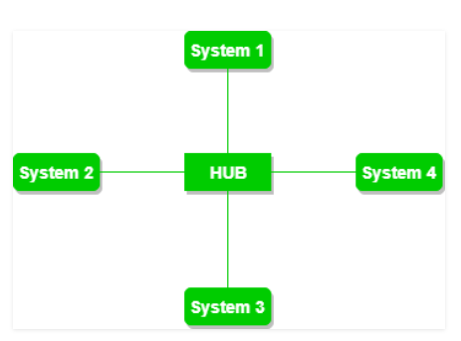
Figure 2: A star topology having four systems connected to single point of connection i.e., hub.
Advantages of this topology:
- If N devices are connected to each other in star topology, then the number of cables required to connect them is N. So, it is easy to set up.
- Each device requires only 1 port i.e. to connect to the hub.
Problems with this topology:
- If the concentrator (hub) on which the whole topology relies fails, the whole system will crash down.
- Cost of installation is high.
- Performance is based on the single concentrator i.e. hub.

Bus Topology: Bus topology is a network type in which every computer and network device is connected to single cable. It transmits the data from one end to another in single direction. No bi-directional feature is in bus topology. It is multi-point connection and a non-robust topology because if the backbone fails the topology crashes.
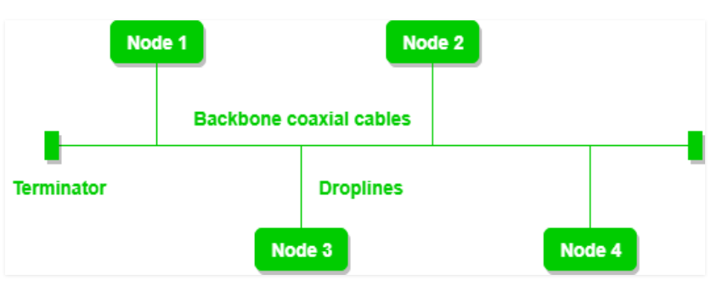
Figure 3: A bus topology with shared backbone cable. The nodes are connected to the channel via drop lines.
Advantages of this topology:
- If N devices are connected to each other in bus topology, then the number of cables required to connect them is 1 which is known as backbone cable and N drop lines are required.
- Cost of the cable is less as compared to other topology, but it is used to build small networks.
Problems with this topology:
- If the common cable fails, then the whole system will crash down.
- If the network traffic is heavy, it increases collisions in the network. To avoid this, various protocols are used in MAC layer known as Pure Aloha, Slotted Aloha, CSMA/CD etc.

Ring Topology: In this topology, it forms a ring connecting devices with its exactly two neighboring devices.
A number of repeaters are used for Ring topology with a large number of nodes, because if someone wants to send some data to the last node in the ring topology with 100 nodes, then the data will have to pass through 99 nodes to reach the 100th node. Hence to prevent data loss repeaters are used in the network.
The transmission is unidirectional, but it can be made bidirectional by having 2 connections between each Network Node, it is called Dual Ring Topology.
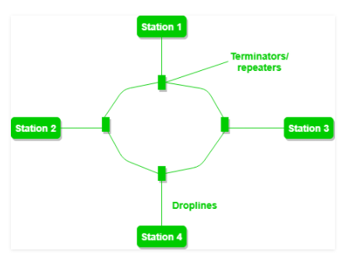
Figure 4: A ring topology comprises of 4 stations connected with each forming a ring..
The following operations takes place in ring topology are:
- One station is known as monitor station which takes all the responsibility to perform the operations.
- To transmit the data, station has to hold the token. After the transmission is done, the token is to be released for other stations to use.
- When no station is transmitting the data, then the token will circulate in the ring.
- There are two types of token release techniques: Early token release releases the token just after the transmitting the data and Delay token release releases the token after the acknowledgement is received from the receiver.
Advantages of this topology:
- The possibility of collision is minimum in this type of topology.
- Cheap to install and expand.
- Problems with this topology: Troubleshooting is difficult in this topology.
- Addition of stations in between or removal of stations can disturb the whole topology.

Tree Topology: This topology is the variation of Star topology. This topology have hierarchical flow of data.
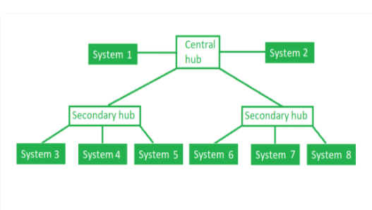
Figure 5: In this the various secondary hubs are connected to the central hub which contains the repeater. In this data flow from top to bottom i.e from the central hub to secondary and then to the devices or from bottom to top i.e. devices to secondary hub and then to the central hub. It is multi-point connection and a non-robust topology because if the backbone fails the topology crashes.
Advantages of this topology:
- It allows more devices to be attached to a single central hub thus it increases the distance that is travel by the signal to come to the devices.
- It allows the network to get isolate and also prioritize from different computers.
Problems with this topology: If the central hub gets fails the entire system fails.
- The cost is high because of cabling.

Hybrid Topology: A combination of two or more topology is known as hybrid topology. For example, a combination of star and mesh topology is known as hybrid topology.
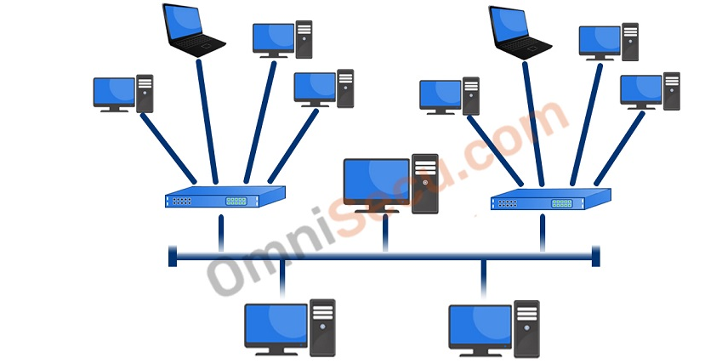
- The combination of various topologies is known as Hybrid topology.
- A Hybrid topology is a connection between different links and nodes to transfer the data.
- When two or more different topologies are combined is termed as Hybrid topology and if similar topologies are connected with each other will not result in Hybrid topology. For example, if there exist a ring topology in one branch of ICICI bank and bus topology in another branch of ICICI bank, connecting these two topologies will result in Hybrid topology.

Advantages of Hybrid Topology:
- Reliable: If a fault occurs in any part of the network will not affect the functioning of the rest of the network.
- Scalable: Size of the network can be easily expanded by adding new devices without affecting the functionality of the existing network.
- Flexible: This topology is very flexible as it can be designed according to the requirements of the organization.
- Effective: Hybrid topology is very effective as it can be designed in such a way that the strength of the network is maximized and weakness of the network is minimized.

Disadvantages of Hybrid topology:
- Complex design: The major drawback of the Hybrid topology is the design of the Hybrid network. It is very difficult to design the architecture of the Hybrid network.
- Costly Hub: The Hubs used in the Hybrid topology are very expensive as these hubs are different from usual Hubs used in other topologies.
- Costly infrastructure: The infrastructure cost is very high as a hybrid network requires a lot of cabling, network devices, etc.

NETWORK DEVICES:

Network device are physical devices that are required for communication and interaction between hardware on a computer network.

Types of network devices -
- Hub
- Switch
- Router
- Bridge
- Gateway
- Modem
- Repeater

HUB -
Hubs are networking devices operating at a physical layer of the Open Systems Interconnection (OSI) model that are used to connect multiple devices in a network. They are generally used to connect computers in a LAN. A hub has numerous ports. A computer which intends to be connected to the network is plugged in to one of these ports. When a data frame arrives at a port, it is broadcast to every other port, without considering whether it is destined for a particular destination device or not. Also, they do not have the intelligence to find out best path for data packets which leads to inefficiencies and wastage.
Hubs do not perform packet filtering or addressing functions; they just send data packets to all connected devices. Collision domain of all hosts connected through hub remains one. A hub can be used with both digital and analog data, provided its settings have been configured to prepare for the formatting of the incoming data. For example, if the incoming data is in digital format, the hub must pass it on as packets; however, if the incoming data is analog, then the hub passes it on in signal form. Transmission mode is half duplex. They generally have fewer ports of 4/12.

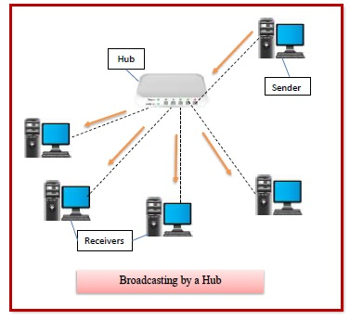

Types of Hubs –
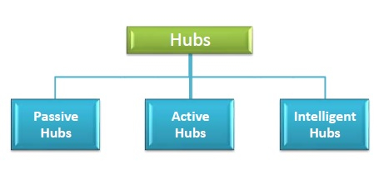

- Passive Hubs − Passive hubs connects nodes in a star configuration by collecting wiring from nodes. They broadcast signals onto the network without amplifying or regenerating them. As they cannot extend the distance between nodes, they limit the size of the LAN. The passive hubs are the connection point for wires that helps to make the physical network. It is capable of determining the bugs and faulty hardware. Simply, it accepts the packet over a port and circulates it to all ports. It includes connectors (10base-2 port and RJ-45) that can be applied as a standard in your network. This connector is connected to all local area network (LAN) devices.
- Active Hubs − Active hubs amplify and regenerate the incoming electrical signals before broadcasting them. They have their own power supply and serves both as a repeater as well as connecting center. Due to their regenerating capabilities, they can extend the maximum distance between nodes, thus increasing the size of LAN. It is able to monitor the data sent to the connected devices. It plays an important role between the connected devices with the help of store technology, where it checks the data to be sent and decides which packet to send first.
- Intelligent Hubs − Intelligent hubs are active hubs that provide additional network management facilities. They can perform a variety of functions of more intelligent network devices like network management, switching, providing flexible data rates etc. These hubs have some kinds of management software that help to analyze the problem in the network and resolve them. It is beneficial to expend the business in networking; the management can assign users that help to work more quickly and share a common pool efficiently by using intelligent hubs. However, it offers better performance for the local area network. Furthermore, with any physical device, if any problem is detected, it is able to detect this problem easily.
SWITCH -
A switch is a data link layer networking device which connects devices in a network and uses packet switching to send and receive data over the network. A switch has many ports, to which computers are plugged in. When a data frame arrives at any port of a network switch, it examines the destination address, performs necessary checks and sends the frame to the corresponding devices. It supports unicast, multicast as well as broadcast communications. A switch is a multiport bridge with a buffer and a design that can boost its efficiency (a large number of ports imply less traffic) and performance. The switch can perform error checking before forwarding data, that makes it very efficient as it does not forward packets that have errors and forward good packets selectively to correct port only. Switch divides collision domain of hosts, but broadcast domain remains same.
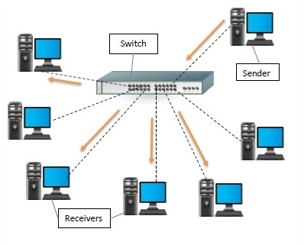

Types of Switches –
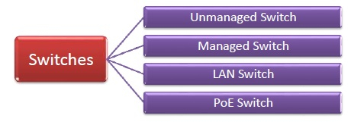
- Unmanaged Switch − These are inexpensive switches commonly used in home networks and small businesses. They can be set up by simply plugging in to the network, after which they instantly start operating. When more device needs to be added, more switches are simply added by this plug and play method. They are referred to as u managed since they do not require to be configured or monitored.
- Managed Switch − These are costly switches that are used in organizations with large and complex networks, since they can be customized to augment the functionalities of a standard switch. The augmented features may be QoS (Quality of Service) like higher security levels, better precision control and complete network management. Despite their cost, they are preferred in growing organizations due to their scalability and flexibility. Simple Network Management Protocol (SNMP) is used for configuring managed switches.

- LAN Switch − Local Area Network (LAN) switches connects devices in the internal LAN of an organization. They are also referred as Ethernet switches or data switches. These switches are particularly helpful in reducing network congestion or bottlenecks. They allocate bandwidth in a manner so that there is no overlapping of data packets in a network.
- PoE Switch − Power over Ethernet (PoE) switches are used in PoE Gogabit Ethernets. PoE technology combine data and power transmission over the same cable so that devices connected to it can receive both electricity as well as data over the same line. PoE switches offer greater flexibility and simplifies the cabling connections.

ROUTER -
Routers are networking devices operating at network layer of the OSI model. They are responsible for receiving, analyzing, and forwarding data packets among the connected computer networks. When a data packet arrives, the router inspects the destination address, consults its routing tables to decide the optimal route and then transfers the packet along this route.
Routers help to transmit packets to their destinations by charting a path through the sea of interconnected networking devices using different network topologies. Most routers can be configured to operate as packet-filtering firewalls and use access control lists (ACLs). Routers, in conjunction with a channel service unit/data service unit (CSU/DSU), are also used to translate from LAN framing to WAN framing. This is needed because LANs and WANs use different network protocols. Such routers are known as border routers. They serve as the outside connection of a LAN to a WAN, and they operate at the border of your network. Routers usually communicate routing and other information using one of three standard protocols: Routing Information Protocol (RIP), Border Gateway Protocol (BGP) or Open Shortest Path First (OSPF).
Routers are general-purpose devices that interconnect two or more heterogeneous networks. They are usually dedicated to special-purpose computers, with separate input and output network interfaces for each connected network. Because routers and gateways are the backbone of large computer networks like the internet, they have special features that give them the flexibility and the ability to cope with varying network addressing schemes and frame sizes through segmentation of big packets into smaller sizes that fit the new network components. Each router interface has its own Address Resolution Protocol (ARP) module, its own LAN address (network card address) and its own Internet Protocol (IP) address. The router, with the help of a routing table, has knowledge of routes a packet could take from its source to its destination. The routing table, like in the bridge and switch, grows dynamically. Upon receipt of a packet, the router removes the packet headers and trailers and analyzes the IP header by determining the source and destination addresses and data type, and noting the arrival time. It also updates the router table with new addresses not already in the table. The IP header and arrival time information is entered in the routing table. Routers normally work at the Network layer of the OSI model.
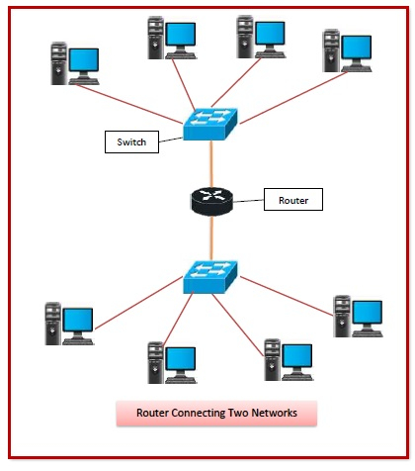

Routing Table -
The functioning of a router depends largely upon the routing table stored in it. The routing table stores the available routes for all destinations. The router consults the routing table to determine the optimal route through which the data packets can be sent.
A routing table typically contains the following entities −
- IP addresses and subnet mask of the nodes in the network
- IP addresses of the routers in the network
- Interface information among the network devices and channels
Routing tables are of two types −
- Static Routing Table − Here, the routes are fed manually and are not refreshed automatically. It is suitable for small networks containing 2-3 routers.
- Dynamic Routing Table − Here, the router communicates with other routers using routing protocols to determine the available routes. It is suited for larger networks having large number of routers.

Types of Routers –

- Wireless Router − They provide Wi-Fi connection Wi-Fi devices like laptops, smartphones etc. They can also provide standard Ethernet routing. For indoor connections, the range is 150 feet while its 300 feet for outdoor connections.
- Broadband Routers − They are used to connect to the Internet through telephone and to use voice over Internet Protocol (VoIP) technology for providing high-speed Internet access. They are configured and provided by the Internet Service Provider (ISP).
- Core Routers − They can route data packets within a given network, but cannot route the packets between the networks. They help to link all devices within a network thus forming the backbone of network. It is used by ISP and communication interfaces.
- Edge Routers − They are low-capacity routers placed at the periphery of the networks. They connect the internal network to the external networks, and are suitable for transferring data packets across networks. They use Border Gateway Protocol (BGP) for connectivity. There are two types of edge routers, subscriber edge routers and label edge routers.
- Brouters − Brouters are specialized routers that can provide the functionalities of bridges as well. Like a bridge, brouters help to transfer data between networks. And like a router, they route the data within the devices of a network.

Bridge -
Bridges are used to connect two or more hosts or network segments together. The basic role of bridges in network architecture is storing and forwarding frames between the different segments that the bridge connects. They use hardware Media Access Control (MAC) addresses for transferring frames. By looking at the MAC address of the devices connected to each segment, bridges can forward the data or block it from crossing. Bridges can also be used to connect two physical LANs into a larger logical LAN. Bridges work only at the Physical and Data Link layers of the OSI model. Bridges are used to divide larger networks into smaller sections by sitting between two physical network segments and managing the flow of data between the two.
Bridges are like hubs in many respects, including the fact that they connect LAN components with identical protocols. However, bridges filter incoming data packets, known as frames, for addresses before they are forwarded. As it filters the data packets, the bridge makes no modifications to the format or content of the incoming data. The bridge filters and forwards frames on the network with the help of a dynamic bridge table. The bridge table, which is initially empty, maintains the LAN addresses for each computer in the LAN and the addresses of each bridge interface that connects the LAN to other LANs. Bridges, like hubs, can be either simple or multiple port. Bridges have mostly fallen out of favor in recent years and have been replaced by switches, which offer more functionality. In fact, switches are sometimes referred to as “multiport bridges” because of how they operate.
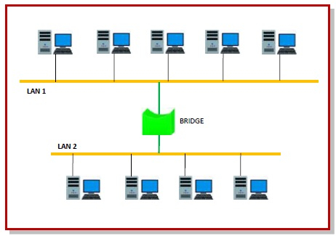
Types of Bridges -
  - Transparent Bridge
As the name suggests, it is an invisible bridge in the computer network. The main function of this bridge is to block or forward the data depending on the MAC address. The other devices within the network are unaware of the existence of bridges. These types of bridges are most popular and operate in a transparent way to the entire networks which are connected to hosts.
This bridge saves the addresses of MAC within a table that is similar to a routing table. This estimates the information when a packet is routed to its position. So it can also merge several bridges to check incoming traffic in a better way. These bridges are implemented mainly in Ethernet networks.
  - Translational Bridge
A translational bridge plays a key role in changing a networking system from one type to another. These bridges are used to connect two different networks like token ring & Ethernet. This bridge can add or remove the data based on the traveling direction, and forward the frames of the data link layer in between LANs which uses various types of network protocols. The different network connections are Ethernet to FDDI/token ring otherwise Ethernet on UTP (unshielded twisted pair) to coax & in between FOC and copper wiring.
  - Source-route Bridge
Source-route Bridge is one type of technique used for Token Ring networks and it is designed by IBM. In this bridge, the total frame route is embedded in one frame. So that it allows the bridge to make precise decisions of how the frame is forwarding using the network. By using this method, two similar network segments are connected to the data link layer. It can be done in a distributed way wherever end-stations join within the bridging algorithm.

Gateway –

A gateway is a network node that forms a passage between two networks operating with different transmission protocols. The most common type of gateways, the network gateway operates at network layer of the OSI model. However, depending upon the functionality, a gateway can operate at any of the seven layers of OSI model. It acts as the entry – exit point for a network since all traffic that flows across the networks should pass through the gateway. Only the internal traffic between the nodes of a LAN does not pass through the gateway.

Gateways normally work at the Transport and Session layers of the OSI model. At the Transport layer and above, there are numerous protocols and standards from different vendors; gateways are used to deal with them. Gateways provide translation between networking technologies such as Open System Interconnection (OSI) and Transmission Control Protocol/Internet Protocol (TCP/IP). Because of this, gateways connect two or more autonomous networks, each with its own routing algorithms, protocols, topology, domain name service, and network administration procedures and policies. Gateways perform all of the functions of routers and more. In fact, a router with added translation functionality is a gateway. The function that does the translation between different network technologies is called a protocol converter.
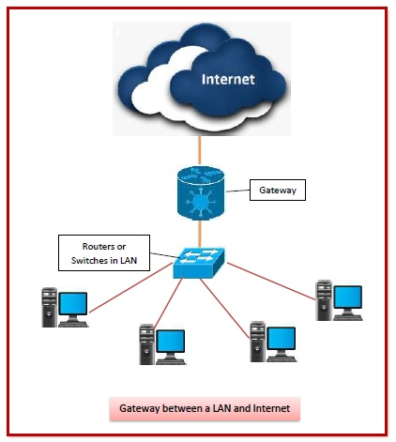

Types of Gateways -
On basis of direction of data flow, gateways are broadly divided into two categories −
- Unidirectional Gateways − They allow data to flow in only one direction. Changes made in the source node are replicated in the destination node, but not vice versa. They can be used as archiving tools.
- Bidirectional Gateways − They allow data to flow in both directions. They can be used as synchronization tools.
On basis of functionalities, there can be a variety of gateways, the prominent among them are as follows −
- Network Gateway − This is the most common type of gateway that provides as interface between two dissimilar networks operating with different protocols. Whenever the term gateway is mentioned without specifying the type, it indicates a network gateway.
- Cloud Storage Gateway − It is a network node or server that translates storage requests with different cloud storage service API calls, such as SOAP (Simple Object Access Protocol) or REST (Representational State Transfer).It facilitates integration of private cloud storage into applications without necessitating transfer of the applications into any public cloud, thus simplifying data communication.
- Internet-To-Orbit Gateway (I2O) − It connects devices on the Internet to satellites and spacecraft orbiting the earth. Two prominent I2O gateways are Project HERMES and Global Educational Network for Satellite Operations (GENSO).
- IoT Gateway − IoT gateways assimilates sensor data from IoT (Internet of Things) devices in the field and translates between sensor protocols before sending it to the cloud network. They connect IoT devices, cloud network and user applications.
- VoIP Trunk Gateway − It facilitates data transmission between plain old telephone service (POTS) devices like landline phones and fax machines, with VoIP (voice over Internet Protocol) network.

Repeater -
A repeater is an electronic device that amplifies the signal it receives and retransmits it at a higher level or higher power so that the signal can cover longer distances, more than 100 meters for standard LAN cables. Repeaters are network devices operating at physical layer of the OSI model that amplify or regenerate an incoming signal before retransmitting it. They are incorporated in networks to expand its coverage area. They are also known as signal boosters.
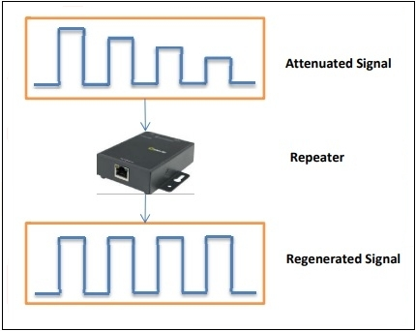
When an electrical signal is transmitted via a channel, it gets attenuated depending upon the nature of the channel or the technology. This poses a limitation upon the length of the LAN or coverage area of cellular networks. This problem is alleviated by installing repeaters at certain intervals.
Repeaters amplifies the attenuated signal and then retransmits it. Digital repeaters can even reconstruct signals distorted by transmission loss. So, repeaters are popularly incorporated to connect between two LANs thus forming a large single LAN. This is shown in the following diagram −
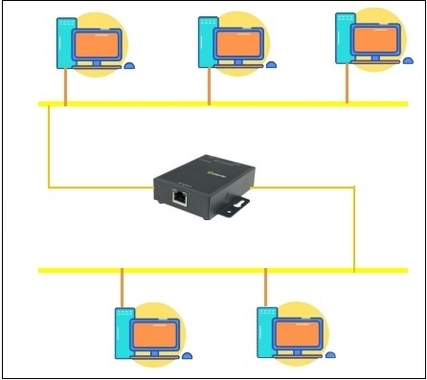

Types of Repeaters -
According to the types of signals that they regenerate, repeaters can be classified into two categories −
- Analog Repeaters − They can only amplify the analog signal.
- Digital Repeaters − They can reconstruct a distorted signal.
According to the types of networks that they connect, repeaters can be categorized into two types −
- Wired Repeaters − They are used in wired LANs.
- Wireless Repeaters − They are used in wireless LANs and cellular networks.
According to the domain of LANs they connect, repeaters can be divided into two categories −
- Local Repeaters − They connect LAN segments separated by small distance.
- Remote Repeaters − They connect LANs that are far from each other.

MODEM –
Modem is a device that enables a computer to send or receive data over telephone or cable lines. The data stored on the computer is digital whereas a telephone line or cable wire can transmit only analog data. The main function of the modem is to convert digital signal into analog and vice versa. Modem is a combination of two devices − modulator and demodulator. The modulator converts digital data into analog data when the data is being sent by the computer. The demodulator converts analog data signals into digital data when it is being received by the computer.
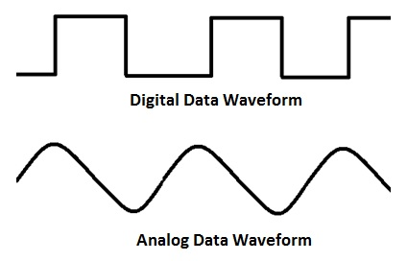

Types of Modem
Modem can be categorized in several ways like direction in which it can transmit data, type of connection to the transmission line, transmission mode, etc.
Depending on direction of data transmission, modem can be of these types −
- Simplex − A simplex modem can transfer data in only one direction, from digital device to network (modulator) or network to digital device (demodulator).
- Half duplex − A half-duplex modem has the capacity to transfer data in both the directions but only one at a time.
- Full duplex − A full duplex modem can transmit data in both the directions simultaneously.

OSI MODEL:
OSI stands for Open Systems Interconnection. It has been developed by ISO – ‘International Organization of Standardization ‘, in the year 1984. It is a 7-layer architecture with each layer having specific functionality to perform. All these 7 layers work collaboratively to transmit the data from one person to another across the globe.

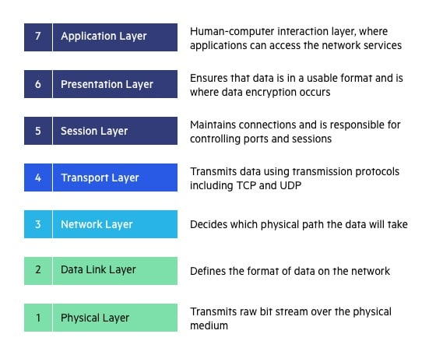
LAYER | NAME | DEVICES | PROTOCOLS
Layer 7 | Application | - | SMTP, HTTP, FTP, POP3, SNMP
Layer 6 | Presentation | - | MPEG, ASCH, SSL, TLS
Layer 5 | Session | - | NetBIOS, SAP
Layer 4 | Transport | - | TCP, UDP
Layer 3 | Network | Routers | IPV5, IPV6, ICMP, IPSEC, ARP, MPLS.
Layer 2 | Data Link | Switch and Bridge | RAPA, PPP, Frame Relay, ATM, Fiber Cable, etc.
Layer 1 | Physical | Hub, repeater, modem and cables | RS232, 100BaseTX, ISDN, 11.

Physical layer
- The lowest layer of the OSI reference model is the physical layer.
- It is responsible for the actual physical connection between the devices. The physical layer contains information in the form of bits.
- It is responsible for transmitting individual bits from one node to the next.
- When receiving data, this layer will get the signal received and convert it into 0s and 1s and send them to the Data Link layer, which will put the frame back together.
- It establishes, maintains and deactivates the physical connection.
- It specifies the mechanical, electrical and procedural network interface specifications.
The functions of the physical layer are:
- Bit synchronization: The physical layer provides the synchronization of the bits by providing a clock. This clock controls both sender and receiver thus providing synchronization at bit level.
- Bit rate control: The Physical layer also defines the transmission rate i.e., the number of bits sent per second.
- Physical topologies: Physical layer specifies the way in which the different, devices/nodes are arranged in a network i.e., bus, star or mesh topology.
- Transmission mode: Physical layer also defines the way in which the data flows between the two connected devices. The various transmission modes possible are: Simplex, half-duplex and full-duplex.

Data Link Layer
- The data link layer is responsible for the node-to-node delivery of the message.
- Main function of this layer is to make sure data transfer is error-free from one node to another, over the physical layer.
- Data Link Layer is divided into two sub layers:
- Link Control (LLC) - This layer is responsible for identity and encapsulating network-layer protocols and allows you to find the error.
- Media Access Control (MAC) - It is responsible for controlling how device in a network gain access to medium and permits to transmit data.
- Framing which divides the data from Network layer into frames.
- Allows you to add header to the frame to define the physical address of the source and the destination machine
- Adds Logical addresses of the sender and receivers
- It is also responsible for the sourcing process to the destination process delivery of the entire message.
- It also offers a system for error control in which it detects retransmits damage or lost frames.
- Datalink layer also provides a mechanism to transmit data over independent networks which are linked together.
- When a single communication channel is shared by multiple devices, MAC sub-layer of data link layer helps to determine which device has control over the channel at a given time.

Network layer
- It is a layer 3 that manages device addressing, tracks the location of devices on the network.
- It determines the best path to move data from source to the destination based on the network conditions, the priority of service, and other factors.
- The Data link layer is responsible for routing and forwarding the packets.
- Routers are the layer 3 devices, they are specified in this layer and used to provide the routing services within an internetwork.
- The protocols used to route the network traffic are known as Network layer protocols. Examples of protocols are IP and Ipv6.

- The sender & receiver’s IP address are placed in the header by the network layer.
The functions of the Network layer are:
- Routing: The network layer protocols determine which route is suitable from source to destination. This function of network layer is known as routing.
- Logical Addressing: In-order to identify each device on internetwork uniquely, network layer defines an addressing scheme. The sender & receiver’s IP address are placed in the header by network layer. Such an address distinguishes each device uniquely and universally.
- Packetizing: A Network Layer receives the packets from the upper layer and converts them into packets. This process is known as Packetizing. It is achieved by internet protocol (IP).

Transport Layer
- The Transport layer is a Layer 4 ensures that messages are transmitted in the order in which they are sent and there is no duplication of data.
- The main responsibility of the transport layer is to transfer the data completely.
- It receives the data from the upper layer and converts them into smaller units known as segments.
- This layer can be termed as an end-to-end layer as it provides a point-to-point connection between source and destination to deliver the data reliably.
The two protocols used in this layer are:
- Transmission Control Protocol
  - It is a standard protocol that allows the systems to communicate over the internet.
  - It establishes and maintains a connection between hosts.
  - When data is sent over the TCP connection, then the TCP protocol divides the data into smaller units known as segments. Each segment travels over the internet using multiple routes, and they arrive in different orders at the destination. The transmission control protocol reorders the packets in the correct order at the receiving end.

- User Datagram Protocol
  - User Datagram Protocol is a transport layer protocol.
  - It is an unreliable transport protocol as in this case receiver does not send any acknowledgment when the packet is received, the sender does not wait for any acknowledgment. Therefore, this makes a protocol unreliable.

Functions of Transport Layer:
- Service-point addressing: Computers run several programs simultaneously due to this reason, the transmission of data from source to the destination not only from one computer to another computer but also from one process to another process. The transport layer adds the header that contains the address known as a service-point address or port address. The responsibility of the network layer is to transmit the data from one computer to another computer and the responsibility of the transport layer is to transmit the message to the correct process.
- Segmentation and reassembly: When the transport layer receives the message from the upper layer, it divides the message into multiple segments, and each segment is assigned with a sequence number that uniquely identifies each segment. When the message has arrived at the destination, then the transport layer reassembles the message based on their sequence numbers.
- Connection control: Transport layer provides two services Connection-oriented service and connectionless service. A connectionless service treats each segment as an individual packet, and they all travel in different routes to reach the destination. A connection-oriented service makes a connection with the transport layer at the destination machine before delivering the packets. In connection-oriented service, all the packets travel in the single route.
- Flow control: The transport layer also responsible for flow control but it is performed end-to-end rather than across a single link.
- Error control: The transport layer is also responsible for Error control. Error control is performed end-to-end rather than across the single link. The sender transport layer ensures that message reach at the destination without any error.

SESSION LAYER:
This layer is responsible for establishment of connection, maintenance of sessions, authentication and it also ensures security.
The functions of the session layer are:
Session establishment, maintenance and termination: The layer allows the two processes to establish, use and terminate a connection.

- Synchronization: This layer allows a process to add checkpoints which are considered as synchronization points into the data. These synchronization point help to identify the error so that the data is re-synchronized properly, and ends of the messages are not cut prematurely and data loss is avoided.

- Dialog Controller: The session layer allows two systems to start communication with each other in half-duplex or full-duplex.

PRESENTATION LAYER:

A Presentation layer is mainly concerned with the syntax and semantics of the information exchanged between the two systems. It acts as a data translator for a network.
This layer is a part of the operating system that converts the data from one presentation format to another format. The Presentation layer is also known as the syntax layer.

Functions of Presentation Layer:
- Translation: The processes in two systems exchange the information in the form of character strings, numbers and so on. Different computers use different encoding methods, the presentation layer handles the interoperability between the different encoding methods. It converts the data from sender-dependent format into a common format and changes the common format into receiver-dependent format at the receiving end.
- Encryption: Encryption is needed to maintain privacy. Encryption is a process of converting the sender-transmitted information into another form and sends the resulting message over the network.
- Compression: Data compression is a process of compressing the data, i.e., it reduces the number of bits to be transmitted. Data compression is very important in multimedia such as text, audio, video.

APPLICATION LAYER:
Application layer interacts with an application program, which is the highest level of OSI model. The application layer is the OSI layer, which is closest to the end-user. It means OSI application layer allows users to interact with other software application.
Application layer interacts with software applications to implement a communicating component. The interpretation of data by the application program is always outside the scope of the OSI model.
Example of the application layer is an application such as file transfer, email, remote login, etc.

The functions of the Application Layers are:
- Application-layer helps you to identify communication partners, determining resource availability, and synchronizing communication.
- It allows users to log on to a remote host
- This layer provides various e-mail services
- This application offers distributed database sources and access for global information about various objects and services.

WIRELESS COMMUNICATION

HISTORY OF WIRELSS COMMUNICATION:
The idea of wireless communication ages long back with the understanding the concepts of electrical and magnetic properties during the early days by different cultures (like Chinese, Greek, Roman etc.) and the experiments and inventions carried out in the 17th and the 18th century by different individuals.

SOME IMPORTANT DATES:
1864 | James Clerk Maxwell provided us with the concept of electromagnetic waves.
1887 | Heinrich Hertz sent and received wireless waves, using a spark transmitter and a resonator receiver.
1895 | Guglielmo Marconi sent morse radio signals over more than a mile.
1901 | Marconi received the morse message "s" (...) sent across the Atlantic.
1904 | J.A. Fleming patented the diode.
1906 | - Lee DeForest patented the triode amplifier.  - First speech wireless transmission, by Fessenden.
1907 | - Commercial Trans-Atlantic Wireless Service, using huge ground stations: 30 x 100m antenna masts.  - Beginning of the end for cable-based telegraphy.
WW I | Rapid development of communications intelligence, intercept technology, cryptography.
1915 | Wireless voice transmission New York to San Francisco.
1920 | Marconi discovers short wave radio, with wavelengths between 10 and 100 meters.
1920 | First commercial radio broadcast in Pittsburgh.
1921 | Police car dispatch radios in Detroit.
1930 | BBC began television experiments.
1935 | First telephone call around the world.
WW II | Rapid development of radio technology.
1968 | Carterphone decision.
1974 | FCC (Federal Communications Commission) allocates 40 MHz for cellular telephony.
1982 | European GSM(Global System for Mobile Communications) and Inmarsat established.
1984 | - Breakup of AT&T.  - Initial deployment of AMPS (Advanced Mobile Phone System) cellular system.  - RBOC (Regional Bell Operating Company) market in operations
1986 | FCC allocates 5MHz extended band.
1988 | TDMA (Time-division multiple access) voted as digital cellular standard in North America.
1992 | GSM (Group Special Mobile) operable Germany D2 system.
1993 | CDMA (Code Division Multiple Access)
1994 | PDCC (Personal Digital Cellular Operable) in Tokyo, Japan
1995 | CDMA operable in Hong Kong.
1996 | Six Broad Band PCS (Personal Communication Services) licensed bands (120 MHz) almost reader 20 billion US dollar
1997 | Broadband CDMA constructed and of the 3rd generation mobile.
1999 | Powerful WLAN systems were evolved, such as Bluetooth. This uses 2.4 MHz spectrum.

GENERATIONS OF WIRELESS COMMUNICATION:

1G:
This the first generation of wireless communication / mobile telecommunication and was launched in Japan by NTT (Nippon Telegraph and Telephone) in the year 1979. The main technological development that set aside the first-generation mobile phones from the other generations was the use of multiple cell sites and the ability to transfer calls from one site to another as the user travelled between cells during a conversation. It uses analog signals. It allows voice call in one country.
The disadvantages of first-generation mobile phones are:
- Voice quality is poor.
- Low battery life.
- Size of the phones were not compact.
- Lack of security.
- Storage capacity was limited.
- Handoff reliability was poor.

2G:
These were the second generation of mobile phones launched in Finland in the year 1991. These cellular devices were based on GSM standards. These devices were capable of message transfer (SMS – Short Message Service), transfer of multimedia like photos but not videos. The later versions of this generation are:
- 2.5G - Based on GPRS (General Packet Radio Service) standards.
- 2.75G – Based on EDGE (Enhanced data rates for GSM Evolution) standards.
The main feature of the devices of these generation was that they were of better quality as compared to the devices of the previous generation. Also, they provided better capacity then the 1G devices.
The disadvantages of 2G devices were:
- They were unable to handle complex data like videos because of which one cannot transfer videos.
- 2G devices required strong digital signals.

3G:
The devices of these generations were introduced in the year 2000. The transmission rate was increased up to 2Mbits/s, that allowed user to send as well as receive large email files. The main feature that set aside the 3G devices from the 2G was the use of packet switching instead of circuit switching for data transmission.
Advantages of 3G devices:
- Mode of communication was fast.
- High speed web.
- Improved security.
- Video Conferencing
- Supports 3D gaming.
- Phone calls, TV streaming, Mobile TV, etc.
Disadvantages of 3G devices:
- Cost of 3G devices were than the devices of the previous generations.
- Required higher bandwidth.
- Size of the devices were not compact.

4G:
These devices are the fourth generation of mobile communication that came in existence in the year 2010. These devices are based on LTE (Long Term Evolution) standards and offer features like
video calling, real time language translation and video voice mail.
It can provide speed from 100Mbps up to 1Gbps.
Advantages of 4G devices:
- Provides better quality of services.
- Improved security.
Disadvantages of this network are:
- Battery consumption is more.
- Implementation is difficult.
- Requirement required are expensive.

Note: -
The basic term used to describe 4G technology is MAGIC. Where:
- M - Mobile multimedia
- A - Anytime anywhere
- A - Anytime anywhere
- A - Anytime anywhere
- G - Global mobility support
- I - Integrated wireless solution
- C - Customized personal service

5G:
It is referred as the fifth-generation technology standard for broadband cellular networks. Unlike other networks, machine to machine communication is possible. This network has the capability to perform Internet of Things (IOT) for smart home and smart city, connected cars etc. This generation of devices are based on lower cost, low battery consumption and lower latency than 4G equipment. The speed offered by this network is around 1Gbits/s as a result of which rate of data transfer is much faster as compared to previous versions.

